CURRICULUM VITAE
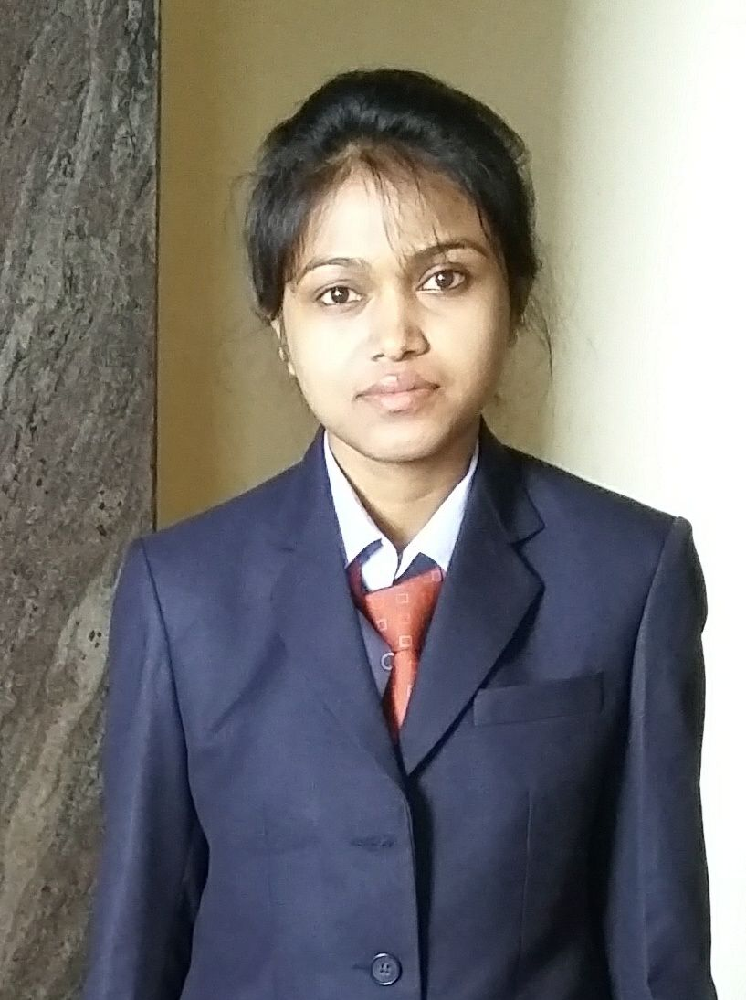

Name : MANISHA ROY

Specialization : Marketing/Finance

Fathers Name : Dr. Amal Chandra Roy

Mother’s Name : Mrs. Arati Roy

Date of Birth : August 28, 1992

Email ID : manisharoy1517@msmindia.org

Contact No. : +91 8486501337/8630384250

Permanent Address : Kokrajhar, UttarSantinagar, W/No.: 2, Near Science College,

P.O-Kokrajhar, Dist.-Kokrajhar, Assam (B.T.C), Pin – 783370

Career Objective:
I’m a highly motivated individual looking to build a career in an environment with committed and dedicated people. I’m willing to stretch myself to fully explore and realize my potential so that I can contribute towards the welfare of Society.

Personal Skills:
● Comprehensive problem solving abilities ● Ability to deal with people diplomatically
● Punctual and Sincere in assignment ● Aspire to learn and adapt to required environment
● Flexible with people and work as a team ● Have computer knowledge (DICAM)

Educational Qualifications:

Qualification | Name of the Institution | (%) | Session
PGDM/MBA (Mkt. & Fin.) | Master School Of Management, Meerut, UP | 75% | 2015-17
B. Com (Fin.) | Commerce College, Kokrajhar, AS | 70% | 2011-14
12th | Commerce College, Kokrajhar, AS | 64% | 2009-11
10th | B.P.C.M Baby Land English Medium High School, Kokrajhar, AS | 66.67% | 2008-09

Work Experience/Internship

Organization | Period of working | CATEGORY/DESIGNATION | JOB PROFILE | LOCATION
1.Vodafone Assam (Part time) | 2012-13 | Receptionist | Billing, sim swap | Kokrajhar (Assam)
2. LIC (Part time) | 1/4/2014 to 30/3/2015 | Data Entry operator | Pivot Table, Name Entry | Kokrajhar (Assam)
3. Bharti Airtel (Internship) | May to July 14/5/16-10/7/16 | CRO | Billing, Sim Swap, Pitch customer, Easy Access, Open Network (D2.0) | Meerut (UP)
4. Club Mahindra  (Trainee ISR) | January 2017 to 31st March | ISR | Potential lead generation, cold calling | Delhi

AWARDS RECEIVED:

- ANUNDORAM BOROOH AWARD 2009 (Assam govt.)

- Winner at Inter-School Race in year 2007, 2008, 2009, 2010 consecutively

- Winner at Master School of Management (Business Plan competition, corporate Story and News Master) year 2016.

Certifications and Trainings:

Mushroom Farming, Tissue culture & Post Harvest methods sponsored by Department of BioTechnology,Govt.of India

Visited Protected Area
Tiger Reserve, Kaziranga National park, Manas National park, Chakrashila Wildlife sanctuary.

Language Known

English, Hindi, Bengali, Assamese & Nepali

Hobbies : Singing, bird watching, cooking

Declaration : I déclare the above mentioned statements are correct and true.

Place:- Signature
Date :- (Manisha Roy)

